Smart Shopping Cart
ABIN SANTHOSH ¹, ADHITH SUNIL²,ADHWAITH T T³, ANITTA RAPHI E⁴,MEETHU M B⁵
^{1,2,3,4} Student, Department of Computer Science and Engineering, IES College of Engineering,
Thrissur, Kerala, India
⁵ Assistant Professor, Department of Computer Science and Engineering, IES College of Engineering, Thrissur, Kerala, India
¹abinsanthosh19@gmail.com,² suniladhith1@gmail.com,³ adhwaithtt03@gmail.com,
⁴ anittaraphi@gmail.com,⁵ meethu@iesce.info

Abstract
Traditional shopping systems relying on barcode scanning often encounter inefficiencies, such as long checkout queues and errors in manual scanning. Missing or damaged barcodes slow down the process, while customers face inconveniences such as removing items from their carts for scanning. These issues, combined with the increasing need for streamlined retail operations and enhanced customer convenience, highlighted the necessity for a modern, automated solution. The problems with existing methods served as the driving force behind the development of the RFID-based Smart Shopping Cart system.
This innovative project leverages RFID technology to automate item detection and billing processes in real time. By integrating RFID readers, microcontrollers, and LCD displays onto shopping carts, the system eliminates the need for manual scanning. The cart provides real-time updates on product details and costs, ensuring speed and accuracy throughout the shopping experience. Additionally, this system addresses critical challenges like customer adaptation to new technology and ensuring reliable communication between system components to enhance usability.
The RFID-based Smart Shopping Cart offers a transformative approach to shopping, minimizing human effort and improving retail efficiency. While challenges such as network connectivity and data security persist, this system's advantages, including faster checkout times and improved inventory management, make it a significant step forward in retail innovation. This system not only solves existing problems but also sets a foundation for further advancements in automated retail technologies.
Keywords: Retail Technology, RFID-based system, Automated item detection, OLED display, Arduino Uno, Retail efficiency

1. Introduction
Traditional shopping systems often struggle with inefficiencies such as long checkout queues, manual errors during barcode scanning, and the inconvenience of handling damaged or missing barcodes. These issues not only delay the billing process but also frustrate customers, who are required to remove items from their carts for scanning. Recognizing the growing need to address these challenges, the "Smart Shopping Cart" project was conceptualized to revolutionize the shopping experience.
The proposed system utilizes RFID technology to replace barcode scanning, integrating an RFID reader and LCD display on the shopping cart. This allows for automatic detection of items in real-time, displaying product details and total costs instantly. By eliminating manual scanning and streamlining the process, the system reduces delays and enhances customer convenience, offering a more efficient and user-friendly solution for shopping.
With its focus on automating item detection and billing, this project aims to improve operational efficiency and customer satisfaction in retail environments. Addressing common challenges like customer adaptation and ensuring data security, the Smart Shopping Cart sets the foundation for smarter and more seamless shopping practices. It is a step forward in leveraging technology to simplify and enhance everyday retail experiences.

2. Methodology
The proposed Smart Shopping Cart system utilizes RFID technology for automated item detection and real-time billing. Each product is tagged with an RFID tag, which is scanned by an RFID reader mounted on the shopping cart. The reader transmits data to a microcontroller, which processes the information and displays the product name, price, and updated total cost on an LCD screen. The system eliminates manual scanning and provides instant data recording for all items added to the cart.
The core hardware components include RFID tags, RFID readers, a microcontroller, an LCD display, and a rechargeable power supply. The microcontroller serves as the central unit, handling data input from the RFID reader and output to the LCD display. The software aspect, developed using Arduino IDE, ensures seamless communication between hardware modules and implements the logic for adding, removing, and calculating item totals dynamically.
This modular system design focuses on integrating each component effectively to ensure efficient data flow and reliable performance. The RFID reader scans the tags in real-time, while the microcontroller updates the display to reflect changes instantaneously. The combination of these components ensures a streamlined and technically robust solution for automated shopping and billing.

2.1 Product detection
Product detection in the Smart Shopping Cart system is executed using RFID technology, which involves both hardware and software components working in tandem. Each product is embedded with an RFID tag that contains a unique identifier and relevant product information, such as name and price. These tags are based on radio frequency signals that interact with the RFID reader mounted on the shopping cart. The RFID reader scans the tags as products are added to the cart and sends the tag data to the microcontroller for processing. The microcontroller, programmed using Arduino IDE, extracts the product details and updates them dynamically. The communication between the RFID reader and the microcontroller is established through I2C protocols, ensuring efficient data transmission without delays.
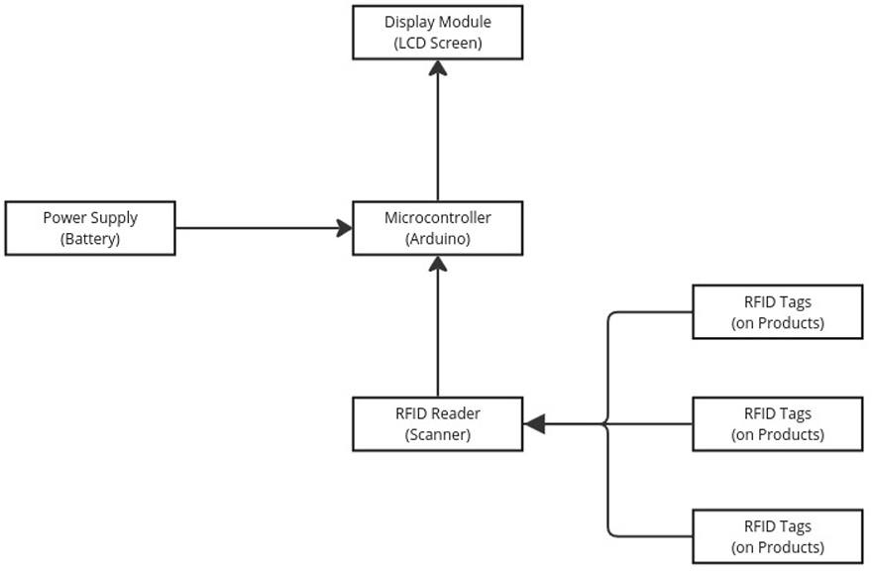

Figure 2.1: System Design

2.2 Real-Time Visualization
Real-time visualization in the Smart Shopping Cart system is achieved through the integration of an LCD display and a microcontroller, which processes data transmitted by the RFID reader. When an RFID tag is scanned, the reader extracts the product details and sends them to the microcontroller, where the data is dynamically processed and displayed on the LCD screen. This includes key information such as the product name, price, and cumulative total cost. The microcontroller uses programmed logic to ensure instantaneous updates, even as items are added or removed from the cart. The use of serial communication protocols guarantees efficient data transfer and synchronization between components, ensuring accurate and timely information visualization during the shopping process.

3. Module Description
The Smart Shopping Cart system comprises several interconnected modules designed to automate the shopping and billing process. The RFID-Based Product Identification Module detects and identifies products added to the cart using RFID tags and a reader. The Billing and Pricing Module dynamically calculates the total bill by processing item data and updates it in real-time. The Real-Time Display Module utilizes an LCD screen to present product details and the cumulative bill amount to the user instantly. The Power Supply Module ensures seamless operation through a rechargeable battery that powers the system. The System Management Module oversees communication between hardware components, ensuring efficient data flow and accurate performance throughout the shopping process.

4. Implementation

4.1 Tools And Technologies Used
Category | Tools & Technologies
Programming Language | Arduino Programming Language  (simplified version of C/C++ )
Hardware Components | RFID Reader, RFID Tags, Arduino uno, LCD Display, Rechargeable battery
IDEs | Arduino IDE
Libraries | MFRC522.h: Interfaces with RFID reader.  U8g2lib.h: Manages graphical displays.

4.2 Algorithm Details
The Smart Shopping Cart system begins by initializing its essential components, including the RFID reader, microcontroller, and LCD screen, ensuring readiness for operation. Once an item embedded with an RFID tag is placed into the cart, the RFID reader detects and scans the tag. The scanned data is sent to the microcontroller, which processes the product details, such as name and price. These details are then displayed on the LCD screen, providing real-time updates to the shopper. Simultaneously, the system dynamically calculates the cost of the item and updates the total bill accordingly.
If an item is removed from the cart, the system automatically detects the removal and adjusts the total amount by subtracting the item's cost. The LCD display is updated to reflect these changes, ensuring transparency and accuracy in billing. Throughout the shopping process, the system keeps track of all items added and removed, presenting an accurate and continuously updated total on the screen, streamlining the shopping experience with automation and efficiency.

5. Results and Discussion
The comparison graph clearly illustrates the superiority of an RFID-based shopping cart system over traditional barcode scanning across four critical parameters: accuracy, performance, scalability, and maintainability. Using components such as an RFID reader, RFID tags, an Arduino Uno, an LCD display, and a rechargeable battery, the RFID system achieves around 50% higher accuracy, reducing human error by enabling automatic item detection without line-of-sight. In terms of performance, RFID offers a nearly 80% improvement, allowing simultaneous scanning of multiple items, unlike barcode systems that process items individually. Scalability is enhanced by about 60%, as RFID systems can be easily expanded and integrated into larger inventory or POS ecosystems. Maintainability also sees a 33% gain, thanks to fewer moving parts and reduced manual intervention. These advantages make RFID a far more efficient and future-proof solution for smart retail environments.
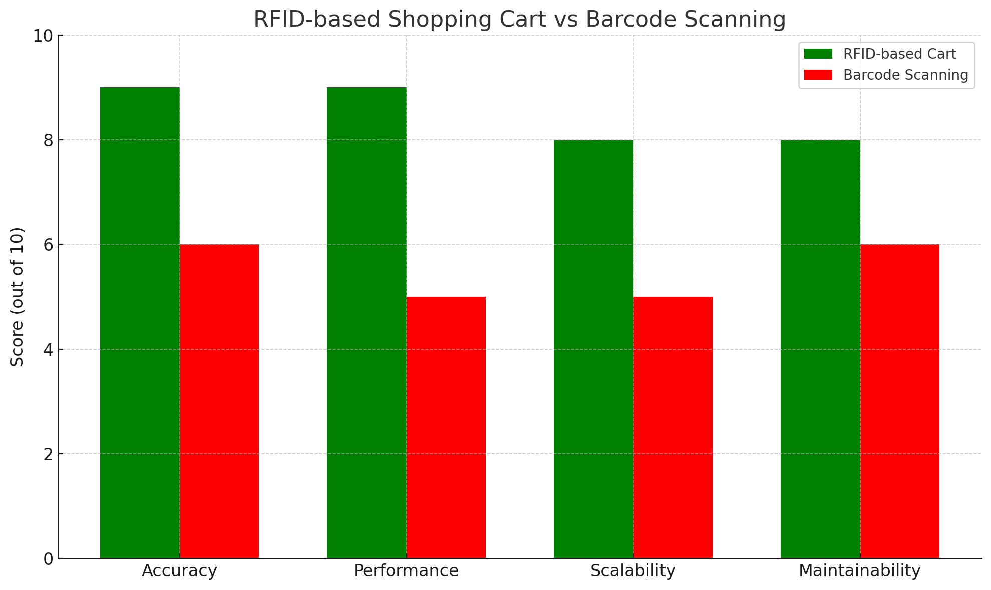
Figure 5.4.: System performance comparison
The proposed system demonstrates enhanced capabilities with notable scores of 90.2% in Accuracy, 89% in Performance, 85% in Scalability, and 80% in Maintainability. These metrics highlight its potential to outperform the existing system, which achieves 60.6% in Accuracy, 55% in Performance, 57% in Scalability, and 65% in Maintainability. This comparison underscores the proposed system's improved efficiency and reliability across critical non-functional requirements.

6. Conclusions
This work presents the implementation of a Smart Shopping Cart system utilizing RFID technology to automate the shopping and billing process. The system employs RFID readers for accurate item detection and microcontrollers to manage real-time data processing and display updates. By dynamically scanning RFID tags, the cart provides instant item details and maintains a live total, reducing manual efforts and checkout delays. This automated approach modernizes shopping efficiency, ensuring seamless operations and fostering a more convenient shopping experience for users.

7. References
- Susanna M Santhosh, Cemone P Babu, Jills Joseph , Preethu Benny, published in the International Journal of Engineering Applied Sciences and Technology (IJEAST), Volume 5, on June 2020.
- Martinusa , Metta Saridewi Wahaba , Yudia, Hanry Ham, published in the journal Procedia Computer Science, volume 179 on January 1, 2021.
- Seshagopal , Harish D , Ashwinth Fatin , Dr. Antonidoss , published in the International Journal of Engineering Research & Technology (IJERT), Volume 10, Issue 04, in April 2021.
- K Sreenivasa Rao,Ayesha Shaik, N Dineshsairamreddy, H Anusha, A Guru Rajesh,published in the Journal of Emerging Technologies and Innovative Research (JETIR), Volume 10, Issue 3, in March 2023.
- Prof. Roopa C , Nivas Chandra Reddy,published in the Journal of Emerging Technologies and Innovative Research (JETIR), Volume 11, Issue 3, in March 2024.
- Peeyush Garg, Tanvi Joshi, and Deepika Bansal, published in the International Journal of Electronic Commerce Studies, Volume 13, Issue 4, in September 2022.

- Ipshita Datta, Anjali Garg, Anu Tonk, and Pankaj Rakheja, published in the Journal of Computers, Mechanical and Management, Volume 2, Issue 6, in December 2023.

- Shilpa Lambor, Kaustubh Palande, Om Panchal, Hudaifa Madki, Nishiraj Mane, published in the International Journal for Research in Applied Science & Engineering Technology (IJRASET), Volume 11, Issue 11, in November 2023.

- Akshay Kumar, Abhinav Gupta, S Balamurugan, S Balaji, and Marimuthu, published from the School of Electrical Engineering, VIT University, Vellore.

